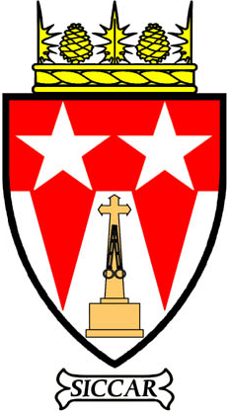
KINROSS
COMMUNITY
COUNCIL

KINROSS
COMMUNITY
COUNCIL

Grant application to Kinross Community Council Newsletter Ltd (charity no. SC040913)
Background and Guidance Notes
The Kinross Community Council Newsletter was founded in 1977 with the aims of informing residents of what the Community Council was doing, to keep the name of Kinross-shire alive and to provide a link between individuals and the community. It soon expanded to include news from the many clubs and groups in the county. Over the years, the Newsletter has grown to be a well-respected source of local news and information with a circulation of over 2000 per issue.
In 2009 Kinross Community Council set up a charitable company, Kinross Community Council Newsletter Limited (KCCNL), to oversee the distribution of profits made by the Newsletter to local good causes. The aims of the charitable company are:
- The advancement of citizenship and community development within Kinross­shire, including support for community events, support for community information, community transport and community welfare (including health care support), support for physical amenities, recreational facilities, voluntary organisations and the financial support of the elderly.
- The prevention and relief of poverty within Kinross-shire.
- The advancement of education within Kinross-shire.
KCCNL welcomes applications from local organisations or individuals for all types of funding. Applications for grants towards running costs will be considered, although organisations will need to demonstrate a certain amount of self-funding. All applications must comply with at least one of the charitable aims listed above.
Applications will be considered at two meetings per year. The deadlines are: 31 March and 30 September. Grants will be issued approximately six weeks after these deadlines.
A list of previous successful applications is available on the kinross.cc website.
If your organisation has accounts, a copy of the most recent set of accounts should be included with your application. Please provide any further information you think would be helpful. Applicants may be asked for further information and clarification if necessary. A report back from successful applicants will be expected within one year. If a grant is not spent within one calendar year, KCCNL reserves the right to have the grant money returned.
Applications must be made in the approved format, either directly on-line via the kinross.cc website or by sending a completed application form to Kinross Community Council’s Grant Application Administrator, Mr Barry Davies. Forms can be downloaded from the kinross.cc website or requested from Mr Davies.
Contact details for Barry Davies: telephone: 01577 865004, email: barrydavies57@btinternet.com
Address: Mr B Davies, Kinross CC Grants Administrator, 60 Lathro Park, Kinross, KY13 8RU.

PROJECT DETAILS
Brief outline of project (including reference to the charitable aims of KCCNL)

Identify the benefits of the project and which section of the community it serves.

How do you intend to assess the success or otherwise of the project?

What is the timescale of the project? When does your project start and end?
Please specify the amount of money being applied for, and if applicable itemise the costs.

Please give an estimate as to the total cost of the project.

Please indicate what other sources of funding have been sought.

CONTACT DETAILS
Name

Address

Telephone number

email

Name of organisation (if applicable)

Position in organisation (if applicable)

Please attach a copy of your accounts.

